INSTITUTE OF REFRACTORIES ENGINEERS
Founded 1961

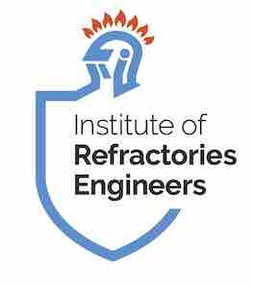
Australian Branch Incorporated
Registered in NSW: ABN 88 109 577 948
President: David Hollott
Secretary: Greg Connor
Treasurer: Dean Tredinnick
E-mail: events-aus@ireng.org

2026 Conference Presentation/Paper Abstract Submission
Theme: Refractory Innovation Driving Industrial Efficiency
Author(s):
Company:
Presenter:
Title:
ABSTRACT (Max 300 words)

Please return to events-aus@ireng.org , with 'Abstract' in the subject line. Further guidance can be obtained by contacting the committee. All submissions will be assessed by our technical committee

